### Smart Door Lock Systems

Jason Leonard

**Abstract**

Smart Lock System is created to solve people’s problems with lock and unlock the door. This paper is aimed to give information to the reader about the Smart Lock System. This paper also tells components, block diagrams, and flowcharts to create this system.

*Index Terms*— door, fingerprint, lock, systems

# INTRODUCTION

Recently, I had an issue to open the door in my boarding house. Sometimes I forgot to lock the door because I am in a hurry to go to university. That is why I am thinking about a computer system that helps me solve the problem. By using a computer system, I don't need to worry anymore about forgot locking the door.

Based on my experience, I try to create the door lock systems. I have three ideas to unlock and lock the door. First, I will create smart door lock systems using a fingerprint sensor. Second, I will make smart door lock using mobile applications. Last, I will create smart door lock using voice recognition. Based on our consideration and our survey, we will choose one system that suits the best for smart door lock systems. After we pick the best system, we start constructing the systems and creating the prototypes.

# SURVEY

To choose the best system, I conduct an FGD by interviewing undergraduate students. Based on the interview result, undergraduate students also have a problem with unlocking and locking a door. They face different issues between one student and other students.

First, they likely to lose cards and lose keys if the door lock systems using cards and keys. Undergraduate students are reckless and sometimes they put the keys randomly and they forgot where the last time they put the keys. Second, the keys and the cards are usually bent because they put them in the wrong places. So finally I decided to create more advanced door lock systems. I had three ideas that are different from the previous systems that students face.

The first one is smart door lock systems using voice recognition. The main reason I don't choose this system because it is not secure. Everyone who says open could unlock this door, this will cause a problem and a thief will sneak in easily.

The second one is smart door lock systems using the mobile application. These systems also have weaknesses such as it would be trouble if students lose their phones. If they lose their phones, people who found the phone will misuse and use that as a crime and another reason is the systems need to rebuild again to make the door lock system works.

The last one is smart door lock systems using a fingerprint sensor. Based on the interview and my opinion, these systems are the best option from the others. These systems are secure and overcome the previous weakness.

# The door lock systems

I choose the smart door lock using a fingerprint sensor. IoT is developed now and it will be improved more in the future. IoT will be used in the future so I also create this system with IoT. I create a system that can be accessed by a mobile phone application. I use the wifi module instead of Bluetooth because wifi has a longer range than Bluetooth. So I combine the two ideas into one. Now, people can unlock and lock the door by using fingerprints and mobile applications. In this section, I will explain the hardware and software that I use to create these systems..

1. Hardware: Arduino Uno

Arduino is the most used platform in robotics. Arduino is developed in Italia in 2005 and it is an open-source platform so Arduino is easier to be implemented. Arduino can be used for Windows, Linux, and Macintosh and use C language for programming. Arduino is easy to understand for all users including students, developers, and hobbyists. Arduino is divided into 19 board models. In this case, I use Arduino Uno. Arduino Uno consists of 8 bit Atmel Micro-controller, the ATmega328P, with an internal permanent memory (EEP-ROM) for both code and data storage, and an internal volatile memory(RAM) for storage of temporary information. Another important feature of Arduino Uno is low power consumption because it can be powered by a 9-volt battery.[1]

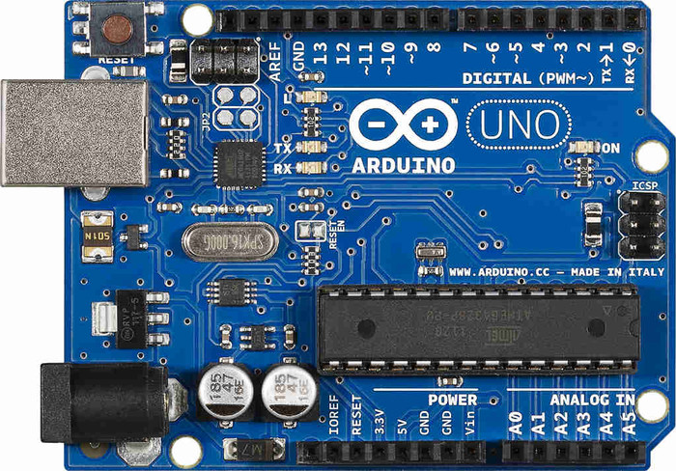

Fig. 1 Arduino Uno

1. Hardware: Fingerprint Sensors

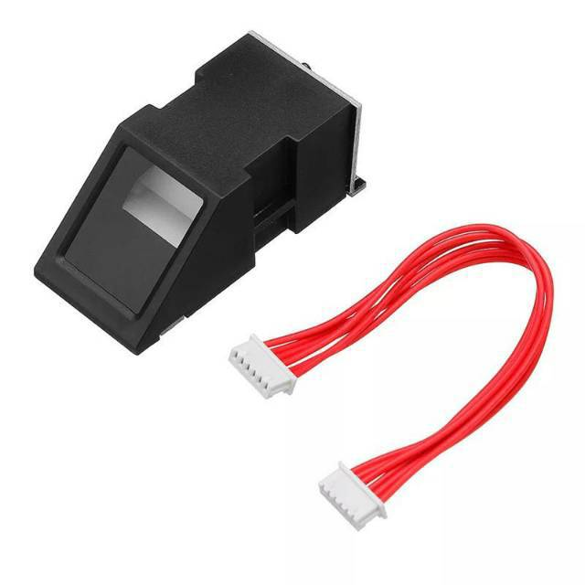Fingerprint scanner on a human fingerprint will produce an image of the ridges and valley. In this project, it has two functions; first to input a new fingerprint as a new owner, and second to scan and read the fingerprint owner. The fingerprint scanner has a processor and memory so the identification process can be done without interrupting the main processor which is Arduino UNO.[2]

Fig. 2 Fingerprint Sensor

1. Hardware: NodeMcu

NodeMcu is embedded microcontroller system with wifi already intact. Which means it no need to use additional wifi Devices. The architecture system on the chip (SOC) is used to communicate between GPIO connecting to the internet and transmit the data through the internet.

Fig. 3 NodeMCU ESP8266 I/O Pin Datasheet

Fig. 3 shows the I/O pin of NodeMCU. To be able to do programming in Arduino IDE, it is necessary to add the existing library that can be downloaded and can run well in mostly operating system.[3]

1. 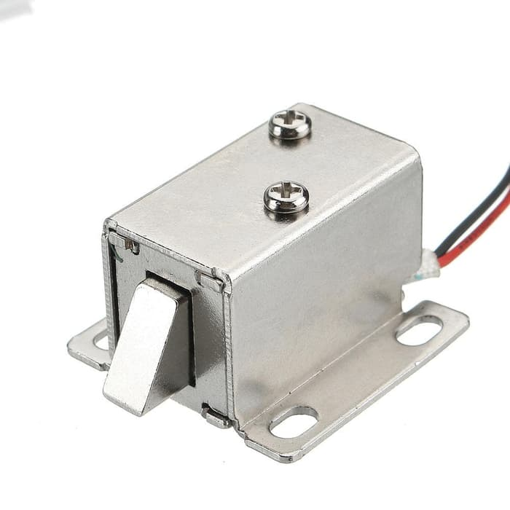Hardware: Solenoid Lock

Fig. 4 Solenoid Lock

Fig. 4 illustrates the picture of Solenoid Lock.

This component is used to unlock and lock the door. It has the same function as a padlock.

1. Software: Arduino IDE

This application can be downloaded in windows and mac. This application is the platform to program your hardware. This platform use C++ programming language. It is compatible with Arduino UNO and ESP8266 NodeMCU.

Adaptor 12 Volt

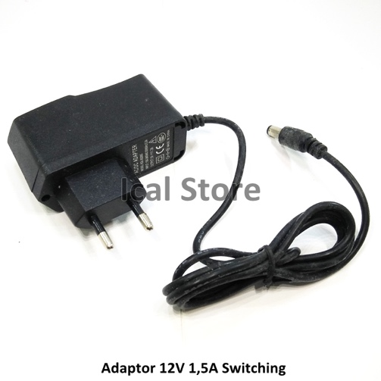

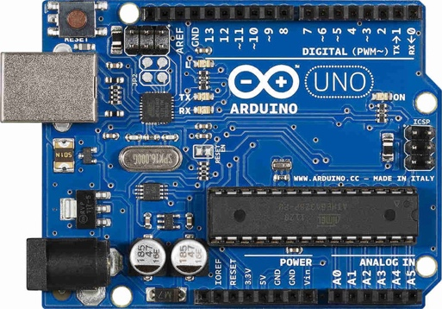Arduino Uno

Fingerprint Sensor



Fig 4. Block Diagram Of The Systems

Solenoid Lock



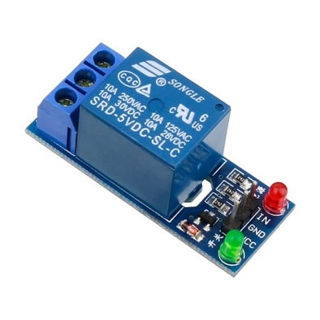 Relay 5 Volt

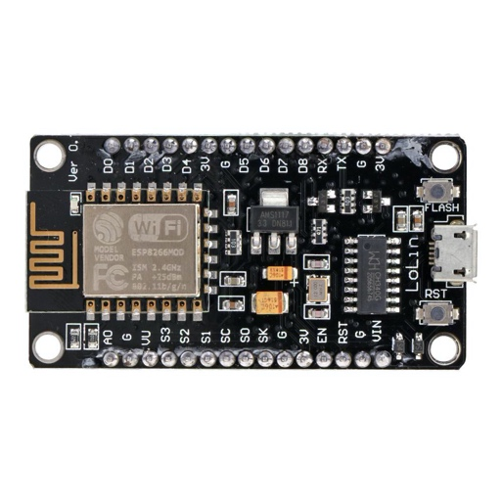 Wifi Module

1. Relay 5 volt is used to protect the components from short circuits
2. Arduino UNO is the microprocessor which is used to control the solenoid lock.
3. Fingerprint Sensor to detect and scan fingerprint owner, if it is matched , then the door will be unlocked
4. Solenoid Lock has the same function as a padlock
5. Wifi Module is used to control the solenoid lock via Wifi
6. Adaptor 12 volt as a power supply.

Scan Fingerprint Owner

If Fingerprint is matched

False True

Door is still locked

Door is Unlocked for 8 Seconds

After 8 seconds, door is locked

Fig. 5 Flowchart of the Fingerprint System

Unlock / Lock Using Applications

Tap the Lock Button

Tap the Unlock Button

Door is still locked

Door is Unlocked Without Delay

Fig. 6 Flowchart of the Mobile Application System

Fig. 5 and Fig. 6 illustrate how the system work. People can unlock and lock the door by using handphone and also the solenoid lock can be unlocked by using fingerprint. Once I received all components, I start constructing my circuit.

# Testing & Evaluation

For testing purposes, I use my fingerprints to test the fingerprint sensor and I also install the app on my handphone and test it using my handphone apllications. I test this system everyday for 10 minutes and it works well.

# Conclusion

This smart door lock system solves the previous problem and make my life easier. And also this system can be implemented in boarding house and private house. The system solve the difficulties that people face with locking/ unlocking the door. The system also follows the development of technology which is by implementing IoT to the system.

References

1. JUNIOR, L. & GUERRA, F. & BRAVO, L. & Hernandez, Marli & Neto, Osvaldo & Martins, Paulo. (2013). A Low-Cost and Simple Arduino-Based Educational Robotics Kit. Journal of Selected Areas in Robotics and Control (JSRC). 3. 1-12.
2. N. I. Zainal, K. A. Sidek, T. S. Gunawan, H. Manser and M. Kartiwi, "Design and development of portable classroom attendance system based on Arduino and fingerprint biometric," The 5th International Conference on Information and Communication Technology for The Muslim World (ICT4M), Kuching, 2014, pp. 1-4, doi: 10.1109/ICT4M.2014.7020601.
3. S. S. Prayogo, Y. Mukhlis and B. K. Yakti, "The Use and Performance of MQTT and CoAP as Internet of Things Application Protocol using NodeMCU ESP8266," 2019 Fourth International Conference on Informatics and Computing (ICIC), Semarang, Indonesia, 2019, pp. 1-5, doi: 10.1109/ICIC47613.2019.8985850.